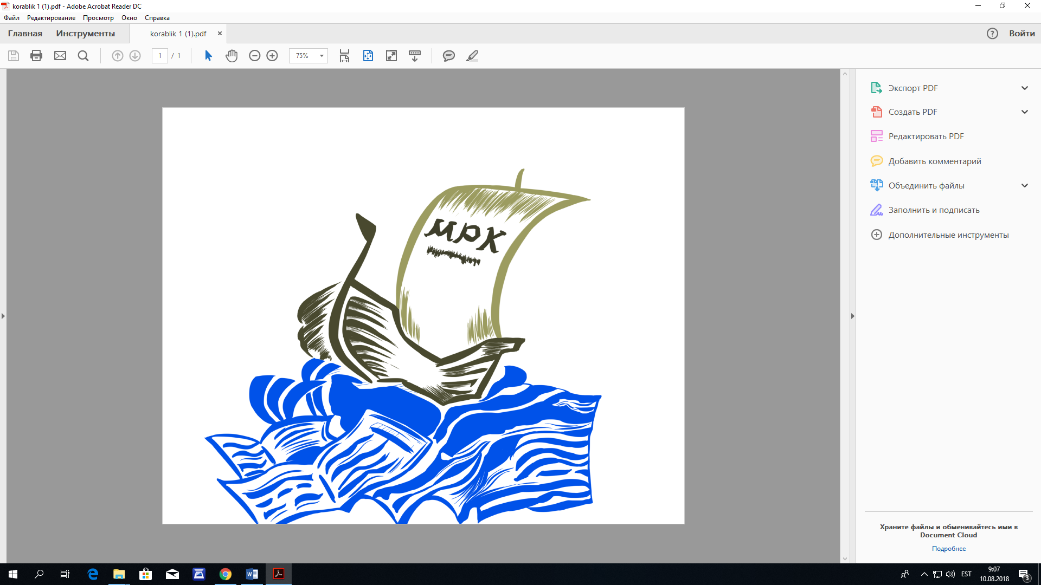

**MAARDU PÕHIKOOLI DIREKTORILE**

**ETTEVALMISTUSKLASSI avaldus**

**Palun minu laps** …………………………………………………………………………………………………

|  |  |  |  |  |  |  |  |  |  |  |  |
| --- | --- | --- | --- | --- | --- | --- | --- | --- | --- | --- | --- |
| Isikukood: |  |  |  |  |  |  |  |  |  |  |  |

vastu võtta Maardu Põhikooli tasulisse eelkooli alates ……………………………………………………

**Maksja/seadusliku esindaja andmed:**

Nimi ……………………………………………………………..

|  |  |  |  |  |  |  |  |  |  |  |  |
| --- | --- | --- | --- | --- | --- | --- | --- | --- | --- | --- | --- |
| Isikukood: |  |  |  |  |  |  |  |  |  |  |  |

(esitamiseks Maksu-ja Tolliametile koolituskulude tasumise kohta – Tulumaksuseadus §26 p1;2)

Maksja elukoha aadress …………………………………………………………………………………………………

Telefoni nr. ………………………………………………………

**Õpilase vanema/eestkostja või hooldaja**

Allkiri……………………………….

Kuupäev……………………………….